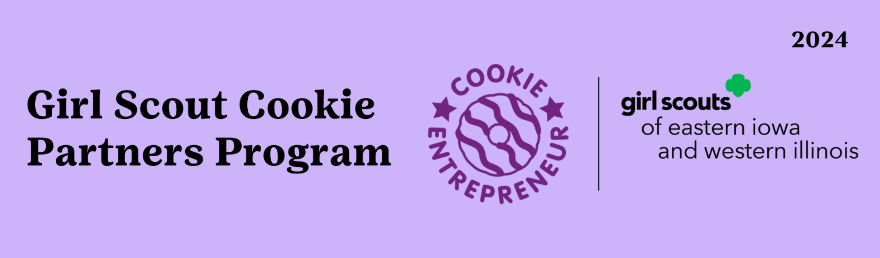

Business Name: _____________________________ Business Contact: __________________
Contact Email: ________________________________ Contact Phone: __________________
Company Address: _____________________________________________________________
City: _______________________________________ State: ________ Zip: _________________
Troop: __________________________ Number of Girls Participating: __________________
Troop Leaders Name: ___________________________________________________________
How will the partner use the cookie purchased? ___________________________________
_______________________________________________________________________________
Sales Pitch Date: _________________ Number of Packages Purchased: ________________

Agreement:
_______________________________, has agreed to participate in the 2024 Cookie Partner Program by agreeing to hear a pitch given by troop _______________. Company named above agrees to purchase _____________ packages of Girl Scout Cookies from troop named above one time, and the troop will deliver cookies to stated company.

Troop Leader Name: ____________________________________________________________
Signature: _____________________________________________ Date: ___________________
Business Contact: ______________________________________________________________
Signature: _____________________________________________ Date: __________________

