October 2019

1 SUD Coach
We are super excited to introduce your new SUD Coach, Laura Torgerud. Laura comes with a wealth of knowledge in regards to supporting, mentoring and managing a service unit. She is here to support you in your leadership role as a SUD. Don’t hesitate to reach out to her with questions, suggestions, ideas, struggles and successes at 651-247-8195 or Ltorgerud@gmail.com.

2 GS Live
The first GS Live was launched yesterday at noon and was amazing. If you missed the live webinar it will be available on our website (scroll down to GS Live Webinar) after 12:00 pm, Friday, September 27th.

3 National Convention
The 55th National Convention will be held in October 2020 in Orlando, FL.
- National delegates have the opportunity to attend and participate in meetings of the national body, represent local views, and take actions that are in the best interest of the Girl Scout movement throughout the nation.
- An election committee will review the applications and present a slate of nominees to be voted on at the Annual Meeting in March 2020. If elected, a delegate will represent the council for a three-year term.
- All volunteers and girls at least 14 years of age by September 30, 2020 are eligible to apply. Application deadline is November 30, 2019. For more information, contact info@GirlScoutstoday.org . Apply today!

4 Service Team Member Training
The Service Team Newsletter that was sent out the first part of September will be sent again on October 7th to any additional new Service Team members. This newsletter will link them directly to the website where they will find their position training.

5 Fall Product Program
The Fall Product Program is quickly approaching!
- Make sure you have all of your girls registered so they can be ready to open their very own online store on October 11.
- Troop in GSEIWI earn 25% proceeds on all sales made during the Fall Product Program. This is the highest troop proceeds earning plan in the nation! In addition, Cadette, Senior, and Ambassador troops can opt-out of rewards for proceeds of 28%.
- This year's dates: In-person & Girl Delivery October 11- October 27 online & direct Shipped October 11 - November 6.
We are looking forward to a great year!

6 Joann Fabrics
Remind your leaders about Girl Scouts and JOANN stores teaming up to inspire girls, troops, and volunteers to explore their individual creativity and use it to make a positive influence in the world by offering a 15% discount in stores and online to Girl Scout members, lifetime members, volunteers, council staff, and parents. To get your Girl Scout Rewards Card complete this application. JOANN stores also host space for troop meetings, events and cookie booths.

7 Girl Scout Store
If you participated in the “Buy Now, Save Later Promotion” and received your coupon you may redeem it between October 14th – 31st by saving $10 on a $25 purchase. Don’t forget that “fun patches” are available for ordering.

8 Faith Based Awards
Visit our website to get information on the religious program that is offered to the girls through the pins of My Promise, My Faith and individual faith recognitions the girls can earn. PRAY is an organization that hosts religious earned pins that girls can earn for the religion of their choice.

9 New Look for Volunteer Essentials
Volunteer Essentials has been reorganized, condensed and broken down into six chapters on our website. There is an option of printing different sections or printing the whole document (just look for the printing icon).

10 Reminders
- Leader Chats
  - In-person: 2nd Wednesday, 6:00 pm, find one near you
  - Online: 4th Thursday, 6:00 pm, join an online chat
- New Leader Resources available on the website
- Volunteer help and support is always available - Just call 800-798-0833 or email info@girlscoutstoday.org.
- Volunteer Girl Scout apparel you can order online using this link, https://orders.corp-imaging.com/girlscouts/# and pick up at your nearest Council Shop. Can’t make it in to pick up your order? Call our 800-798-0833 number or email info@ for shipping options
- New Office & Store Hours available here.
- View a full listing of Events and Anytime Activities on our website
- Leader Low-Down - Click her for details and registration
- Please remind troop leaders to complete their Troop Information Update and submit it
- Send your leaders to the website – everything they need for troop leadership is available online
- Welcome and introduce new leaders at Leader Meetings

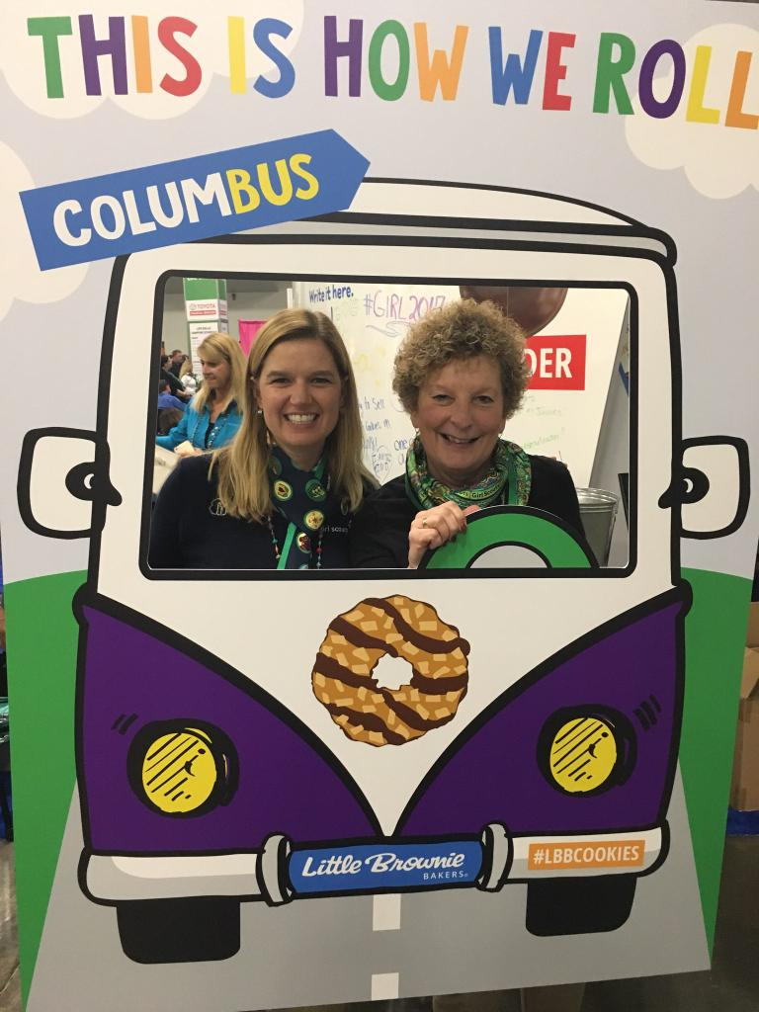
Nikki & Cheryl attended the 2017 National Convention in Columbus and had so much fun they are going to Orlando in October 2020 and are looking for delegates to attend with them!!

Want to have some “fun” and “roll” with us?

Apply today!

