Flag Ceremony (Narrative)

Please be prepared to have some small flags to use for your ceremony to make it look real.

Flag Ceremonies
A flag ceremony honors the American flag as the symbol of our country and all the hopes, dreams, and people it consists of. Flag ceremonies may be used for:
- Opening or closing meetings
- Opening or closing special events
- Beginning or closing a day
- Honoring a special occasion or special person
- Retiring a worn flag
Flag ceremonies may take place in meeting rooms, outdoor settings, large auditoriums, on stage, even on horseback. All flag ceremonies share one thing—respect for the flag.
Handling the American Flag:
The display of our American Flag is governed by law to ensure that it will be treated with the respect due the flag of a great nation. This is known as the Flag Code. Some of the rules most useful for Girl Scouts are:
- The flag, when carried in a procession with other flags, should be either on the marching right or, if there is a line of other flags, in front of the center of that line.
- The flag should be hoisted briskly and lowered slowly with dignity.
- The flag should never be allowed to touch anything beneath it, nor should it ever be carried flat or horizontally - always aloft and free.
- Never use the flag as a cover or place anything on top of it.
- No disrespect of any kind should be shown to the flag of the United States. It should be kept clean.
- When you display the flag on a wall or in a window where people see it from the street, it should be displayed flat with the blue part at the top and on the flag’s own right (which is the observer’s left).
Flag Ceremony Guidelines
Keep it simple. Emphasis needs to be on respect for the flag rather than on the commands or techniques. Adults can ask girls these questions when planning:
- Who will carry the flag?
- Who will be the color guards?
- Who will give the directions for the ceremony?
- What song will be sung? Who will sound the pitch and start the song?
- Will a poem or quotation be included? Who will say or read it?
- After the Pledge of Allegiance, will the Girl Scout Promise and the Law be said?
- In what order will the parts of the ceremony take place?
- When will the group practice?
- Where will the flags be placed at the end of the ceremony?
Terms Used in a Flag Ceremony
The color bearer (or flag bearer) is the person who carries the flag. There is one color bearer for each flag used in the ceremony.
The color guard is a team that guards the flags. Any even number of guards may be used, but usually four or six girls are sufficient.
The Girl Scout in charge (or caller) is a designated Girl Scout who announces or calls each part of the ceremony.
Possible Commands for a Flag Ceremony
"Girl Scouts, attention." Used to announce that the flag ceremony is to begin.
"Color guard, advance." This signals the color guard to advance with the flags, or advance to pick up the flags.
"Color guard, post the colors." This directs the color guard to place the flag in flag standards, or to attach the grommets to a flag pole rope. If posting the flag, the American flag is the last to be posted and the first to be picked up afterwards. (American flag is always the highest)

"Color guard, honor your flag." The color guard salutes the American flag.
"Please join us in saying the Pledge of Allegiance."
“Please recite the Girl Scout Promise” (Followed by an appropriate song, quotation or poem, if so desired.)
“Color Guard, dismissed”. The color guard leaves the flags in the stands and joins the rest of the group.
Girl Scouts, dismissed”. Girls may leave in formation or be at ease where they have been standing.

After reviewing the commands ask for volunteers to come forward to take on the different rolls. Have the rest of the group stand in horseshoe formation .
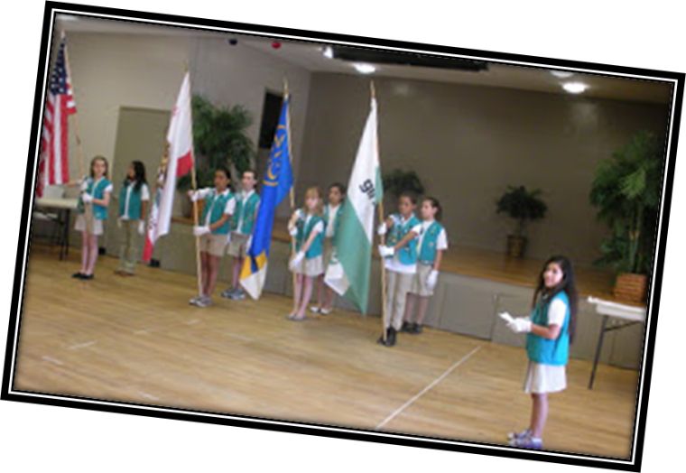

Flag Ceremony (Handout)

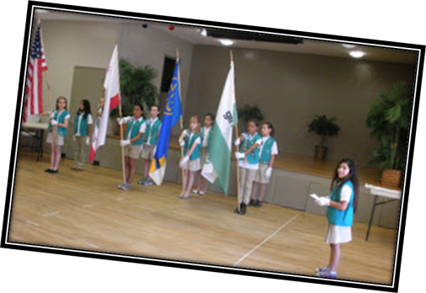
Flag Ceremony Guidelines
Keep it simple. Emphasis needs to be on respect for the flag rather than on the commands or techniques. Adults can ask girls these questions when planning:
- Who will carry the flag?
- Who will be the color guards?
- Who will give the directions for the ceremony?
- What song will be sung? Who will sound the pitch and start the song?
- Will a poem or quotation be included? Who will say or read it?
- After the Pledge of Allegiance, will the Girl Scout Promise and the Law be said?
- In what order will the parts of the ceremony take place?
- When will the group practice?
- Where will the flags be placed at the end of the ceremony?
Terms Used in a Flag Ceremony
The color bearer (or flag bearer) is the person who carries the flag. There is one color bearer for each flag used in the ceremony.
The color guard is a team that guards the flags. Any even number of guards may be used, but usually four or six girls are sufficient.
The Girl Scout in charge (or caller) is a designated Girl Scout who announces or calls each part of the ceremony.
Possible Commands for a Flag Ceremony
"Girl Scouts, attention." Used to announce that the flag ceremony is to begin.
"Color guard, advance." This signals the color guard to advance with the flags, or advance to pick up the flags.
"Color guard, post the colors." This directs the color guard to place the flag in flag standards, or to attach the grommets to a flag pole rope. If posting the flag, the American flag is the last to be posted and the first to be picked up afterwards. (American flag is always the highest)
"Color guard, honor your flag." The color guard salutes the American flag.
"Please join us in saying the Pledge of Allegiance."
“Please recite the Girl Scout Promise” (Followed by an appropriate song, quotation or poem, if so desired.)
“Color Guard, dismissed”. The color guard leaves the flags in the stands and joins the rest of the group.
Girl Scouts, dismissed”. Girls may leave in formation or be at ease where they have been standing.

